**Thank you for applying for** the data science internship at Happie.

Due to the high number of applicants, we have decided to do an assessment prior to the interviews. You have until **December 20th** to do the exercise below.

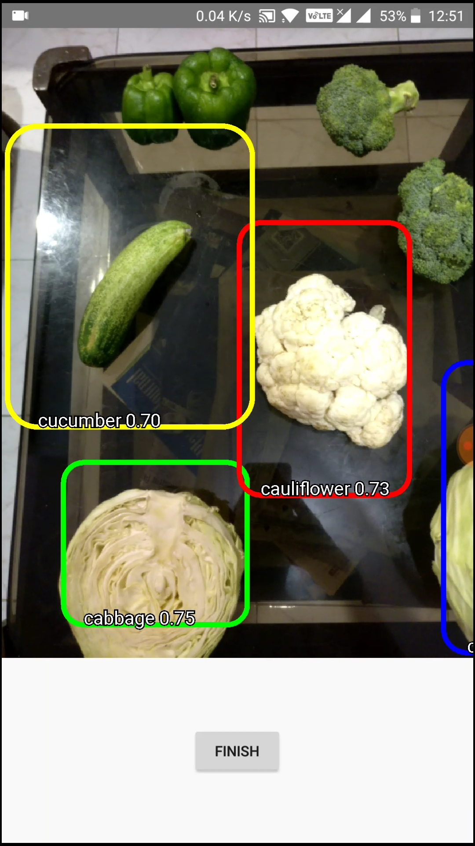

# Objective:

Write an algorithm that is able to detect fruits and vegetables:

* based on a input picture with a **single fruit** / vegetable
* (bonus points) based on a input picture with **multiple fruits** / vegetables

# Rules:

* You have to use Python but can use a Jupyter Notebook or whatever you prefer
* The code needs to be written by you, of course you can utilize existing Python packages.
* Report on accuracy and explain your approach to tackle the problem above
* It does not need to be 100% perfect!

# Dataset:

<https://www.kaggle.com/datasets/moltean/fruits>

# Done with the exercise or have questions?

Send an email to [dennis@happie.ch](mailto:dennis@happie.ch)

